

BOAT ASIA 20-23 APRIL 2006
SENTOSA COVE SINGAPORE
Please Return Before: 5 March 2006
HOTEL RESERVATION FORM
Stand No:

Please Return Before: 19 MARCH 06

Company: ___________________________________________________Attn: __________________________
Email : ___________________________________________________Date: __________________________ Telephone: ___________________________________________________Fax: __________________________
(To avoid any miscommunication, please ensure that the above information is completed and printed clearly)

Return to : Star Route Pte Ltd Attention: Ms Lyn Chan
67 Beach Road, #01-01 Telephone: 65-6334 9029
Beach Junction Telefax: 65-6338 9078
Singapore 189688 E-mail: lyn@starroute.com.sg

Special discounted rates at the official hotels have been secured by SIM. As the room situation is expected to be extremely critical during the event period, reservations made after 5 March 2006 is subject to room availability and a higher room rate may apply.

OFFICIAL HOTELS – Please tick the hotel of your preference below.

Preference | Hotels | Category | Estimated Time to Event Venue | Single/Twin Room only | Breakfast  Rate | Early bird Promotion
 | Pan Pacific Singapore | 5 star | 25 mins drive | S$220.00 | S$32.00 | Complimentary Breakfast
 | *Shangri-La Rasa Sentosa Resort | 5 star | 7 mins drive | S$210.00 | S$30.00 | * Complimentary Upgrade to Pool View
 | Allson Hotel | 4-star | 25 mins drive | S$135.00 | S$16.00 | Complimentary Breakfast
 | City Bayview | 3- star | 25 mins drive | S$130.00 | S$12.00 | Complimentary Breakfast
 | Oxford Hotel | Budget | 25 mins drive | S$90.00 | S$10.00 | Complimentary Breakfast

Early Bird Promotion:
Forward your reservations to us by 5 March 06 and enjoy daily complimentary breakfast (single occupancy), except *.

- The above room rate is subject to 10% service charge and 5% government tax and 1%cess.
- All bookings are subject to 3% administrative charge.
- A daily morning/evening transfer will be provided to/from SENTOSA COVE (exhibition venue) from/to all the above Official Hotels.

BOOKING DETAILS

Surname / Family Name | First Name | Room Type (please tick) | Check-in Date/Time | Check-out Date/Time
 |  | [ ] Single [ ] Twin [ ] Double
 |  | [ ] Single [ ] Twin [ ] Double
 |  | [ ] Single [ ] Twin [ ] Double

PAYMENT DETAILS
As room rates are specially negotiated for the exhibition, full room charges should be paid to Star Route Pte Ltd by 5 March 2006 in order to secure the booking.
Any cancellation after 5 March 2005 is subject to a one (1) night cancellation charge.

[ ] CREDIT CARD
Credit Card: Master card/Visa Number__________________________________________________ Card Expiry Date: _____________________ (MM/YY)

Cardholder’s Name: ________________________________________________________________ Signature: _________________________________

[ ] OR BANK TRANSFER (subjected to S$30 Bank charges)
Account Name: Star Route Pte Ltd Account Number: 432-300-088-8
Bank : United Overseas Bank Limited (UOB), Jalan Sultan Branch, 200 Jalan Sultan, #01-06 Textile Center, Singapore 199018

A confirmation letter, with the accompanying payment and cancellation policies, will be sent to your office within 3 working days upon receipt of this booking form.

AIRPORT TRANSFER REGISTRATION

Type | Limousine  (Merz E200) | Coach  (44 seater)
Airport Transfer (per vehicle/per way) | S$ 55.00 | S$ 85.00
City transfer (per vehicle/per way) | S$ 55.00 | S$ 85.00
Disposal per hour (minimum 3 hours) | S$ 50.00 | S$ 55.00
Midnight Surcharge (2300-0700 hours) | S$ 10.50 | S$ 25.00

- Please provide flight details on a separate sheet for transfer request.
- Transfer are available from 0000-2400 hrs daily
- The above charge are inclusive of the of 5% GST & Service of co-ordinator available on-site of boarding

Optional Sightseeing Tour
This is a great opportunity to discover the facet of Singapore that you have never seen.
Please tick ( ) | Preferred Date of tour | Tour Name | Duration  /Pick-Up Time | Price
 |  | Peranakan Trail  (with food tasting) | 3.5 hrs / 0830 hrs | S$ 39.00(Adult)  S$ 19.00 (Child)
 |  | Morning at the Zoo  ( with jungle breakfast) | 4 hrs / 0800 hrs | S$ 52.00(Adult)  S$ 27.00(Child)
 |  | Jurong Birdpark  (with breakfast with the birds) | 4 hrs / 0800 hrs | S$ 52.00(Adult)  S$ 27.00(Child)
 |  | Sentosa Underwater World | 4 hrs / 0800 hrs | S$ 51.00(Adult)  S$ 26.00(Child)
 |  | Afternoon Till Sunset @ Sentosa | 6.5 hrs / 1330 hrs | S$ 56.00(Adult)  S$ 31.00(Child)
 |  | Night Safari  (with dinner) | 4 hrs / 1800 hrs | S$ 61.00(Adult)  S$ 35.00(Child)

Above fares are subject to availability & changes without prior notice.

For reservation of the tour, please call Lyn Chan of Star Route at 6334 9029 or you may email your request to lyn@starroute.com.sg for further details.


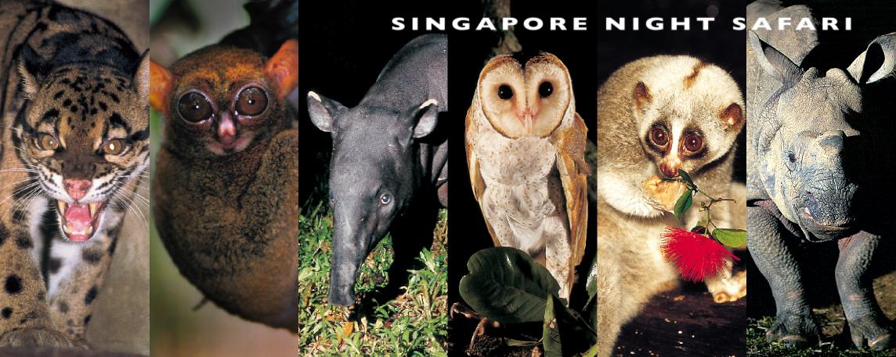







Image courtesy of the Singapore Zoological Garden & Singapore Tourism Board

