

The Gateway To German Technology And Lifestyle 24-26 March 2006
Suntec Singapore International
Convention &Exhibition Centre

Hall /Booth No:
HOTEL RESERVATION FORM

Please Return Before: 23 February 2006

Company: ___________________________________________________Attn: __________________________
Email : ___________________________________________________Date: __________________________ Telephone: ___________________________________________________Fax: __________________________
(To avoid any miscommunication, please ensure that the above information is completed and printed clearly)

Return to : Star Route Pte Ltd Attention: Ms Lyn Chan
67 Beach Road, #01-01 Telephone: 65-6334 9029
Beach Junction Telefax: 65-6338 9078
Singapore 189688 E-mail: lyn@starroute.com.sg

Special discounted rates at the official hotels have been secured by SGC. As the room situation is expected to be extremely critical during the event period, reservations made after 23 February 2006 is subject to room availability and a higher room rate may apply.

OFFICIAL HOTELS – Please tick the hotel of your preference below.

Preference | Hotels | Category | Single/twin Room only | Room With Single Breakfast | Room With  Twin Breakfast
 | Conrad Contennial | 5 star | N.A. | S$250.00 | S$300.00
 | Oriental Singapore | 5 star | S$230.00 | S$245.00 | S$265.00
 | Novotel Clark Quay | 4 star | S$145.00 | S$160.00 | S$180.00

- The above room rate is subject to 10% service charge and 5% government tax and 1%cess.
- All bookings are subject to 3% administrative charge.
- Special rates can also be arranged for non-official hotels of your choice. Please email your request to the Official Travel Agent.
- The following transfer rates are specially extended to the participants attending the event:

Type | Limousine (Merz E200) | Coach (44 seater)
Airport Transfer (per vehicle/per way) | S$ 45.00 | S$ 85.00
City transfer (per vehicle/per way) | S$45.00 | S$ 85.00
Disposal per hour (minimum 3 hours) | S$ 40.00 | S$ 55.00
Midnight Surcharge (2300-0700 hours) | S$ 10.50 | S$ 25.00

- Please provide flight details on a separate sheet for transfer request.
- Transfer are available from 0000-2400 hrs daily
- The above charge are inclusive of the of 5% GST & Service of co-ordinator available on-site of boarding

BOOKING DETAILS

Surname / Family Name | First Name | Room Type (please tick) | Check-in Date/Time | Check-out Date/Time
 |  | [ ] Single [ ] Twin [ ] Double
 |  | [ ] Single [ ] Twin [ ] Double
 |  | [ ] Single [ ] Twin [ ] Double

PAYMENT
As room rates are specially negotiated for the exhibition, full room charges should be paid to Star Route Pte Ltd by 23 February 2006 in order to secure the booking.

[ ] CREDIT CARD
Credit Card: Master card/Visa Number__________________________________________________ Card Expiry Date: _____________________ (MM/YY)

Cardholder’s Name: ________________________________________________________________ Signature: _________________________________
[ ] OR BANK TRANSFER (subjected to S$30 Bank charges)
Account Name: Star Route Pte Ltd Account Number: 432-300-088-8
Bank : United Overseas Bank Limited (UOB), Jalan Sultan Branch, 200 Jalan Sultan, #01-06 Textile Center, Singapore 199018

A confirmation letter, with the accompanying payment and cancellation policies, will be sent to your office within 3 working days upon receipt of this booking form.

AIRPORT TRANSFER REGISTRATION

Type | Limousine  (Merz E200) | Coach  (44 seater)
Airport Transfer (per vehicle/per way) | S$ 45.00 | S$ 85.00
City transfer (per vehicle/per way) | S$45.00 | S$ 85.00
Disposal per hour (minimum 3 hours) | S$ 40.00 | S$ 55.00
Midnight Surcharge (2300-0700 hours) | S$ 10.50 | S$ 25.00

- Please provide flight details on a separate sheet for transfer request.
- Transfer are available from 0000-2400 hrs daily
- The above charge are inclusive of the of 5% GST & Service of co-ordinator available on-site of boarding

Optional Sightseeing Tour
This is a great opportunity to discover the facet of Singapore that you have never seen.
Please tick ( ) | Preferred Date of Tour | Tour Name | Duration / Pick-Up Time | Price
 |  | Peranakan Trail  (with food tasting) | 3.5 hrs / 0830 hrs | S$ 39.00(Adult)  S$ 19.00 (Child)
 |  | Morning at the Zoo  (with jungle breakfast) | 4 hrs / 0800 hrs | S$ 52.00(Adult)  S$ 27.00(Child)
 |  | Jurong Birdpark  (with breakfast with the birds) | 4 hrs / 0800 hrs | S$ 52.00(Adult)  S$ 27.00(Child)
 |  | Sentosa Underwater World | 4 hrs / 0800 hrs | S$ 51.00(Adult)  S$ 26.00(Child)
 |  | Afternoon Till Sunset @ Sentosa | 6.5 hrs / 1330 hrs | S$ 56.00(Adult)  S$ 31.00(Child)
 |  | Night Safari  (with dinner) | 4 hrs / 1800 hrs | S$ 61.00(Adult)  S$ 35.00(Child)

Above fares are subject to availability & changes without prior notice.

For reservation of the tour, please call Lyn Chan of Star Route at 6334 9029 or you may email your request to lyn@starroute.com.sg for further details.


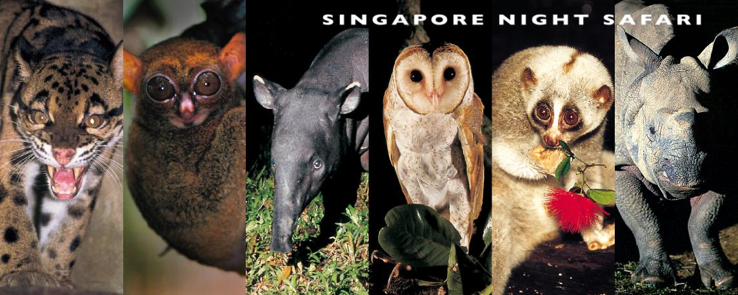






Image courtesy of the Singapore Zoological Garden & Singapore Tourism Board

Hotel Information:

Conrad Centennial Hotel
2 Temasek Boulvard, Singapore 038982
Hotel Description:
A luxury hotel located downtown in Singapore's business, shopping and entertainment districts. -Elegant bedrooms with value added amenities- 484 Rooms & 25 Suites. The hotel's key location and luxurious facilities are complemented by excellent service from a team of multi-lingual staff.
NEAR BY
Shopping and entertainment district of Marina Bay, Millenia Walk And Suntec City
Direct access via tunnel & covered walkways to 1,000 exciting shops
300 mouth-watering restaurants
4 banks
Carrefour Hypermarket
SUNTEC International Convention and Exhibition Centre offering 35,000 square metres of conventions & exhibitions & 31 meeting rooms
A short distance to the Central Business and Financial Districts of Raffles Place and Shenton Way
Walking distance to attractions and museums, the Esplanade-Theatres on the Bay Concert Halls, Civic and Theatre Districts.
Raffles City MRT Station
The Oriental Singapore
5 Raffles Avenue, Singapore 039797
Hotel Description:
The Oriental is Singapore's only Mandarin Oriental hotel, combining spectacular architectural design and a prime waterfront location with the finest standards of comfort and service. The hotel has been continually singled out to receive international and local recognition, placing it among the world's top hotels.
Location Round-Up:
Marina Square, next to Suntec City. Within minutes to Shenton Way and Orchard Road.

Novotel Clarke Quay Hotel – Singapore

177A River Valley Road, Singapore 179031

Hotel Description:
Along the banks of the historic Singapore River, next to the exciting Clarke Quay, mere minutes away from the central business hub and famed Orchard Road shopping paradise - yet, comfortably snuggled beyond the hustle and bustle of the city to offer its guests a relaxing retreat with an inviting old world charm...Only one hotel can offer you a true advantage of the best of both worlds, Hotel New Otani. Come, step into a world of traditional hospitality...and embrace the heart and soul of Singapore!
Location Round-Up:
Located ten minutes away, the Historic Museum & Art Gallery offers the viewer a taste of history and culture not found elsewhere.

