THE CONSTRUCTION LAW CONFERENCE 16-17 October 2006

GRAND COPTHORNE WATERFRONT HOTEL

Hall / Booth No
HOTEL RESERVATION FORM

Please Return Before: 1 September 2006

Company: _________________________________________________Attn: _______________________
Email : _________________________________________________Date: ________________________
Telephone: ________________________________________________ Fax: ________________________
(To avoid any miscommunication, please ensure that the above information is completed and printed clearly)

Return to: Star Route Pte Ltd Attention: Ms Lyn Chan/Mr Yiming Zhong 67 Beach Road, #01-01 Telephone: 65-6334 9029/28
Beach Junction Telefax: 65-6338 9078
Singapore 189688 E-mail: lyn@starroute.com.sg
yiming@starroute.com.sg
____________________________________________________________________________________
As the room situation is expected to be extremely critical during the event period, reservations made after 1 September 2006 is subject to room availability and a higher room rate may apply.

OFFICIAL HOTELS – Please tick the hotel of your preference below.

Preference | Hotels | Category | Distance to Event Venue | Single/Twin Room only | Breakfast  Rate
 | Grand Copthorne Waterfront | 5-star | Event hotel | S$200.00 | S$20.00
 | Copthorne Kings Hotel | 4-star | Opposite | S$175.00 | S$15.00
 | Riverview Hotel | 3-star | Besides | S$165.00 | S$15.00
 | Miramar Hotel | 3-star | 7 Mins Walking distance | S$165.00 | S$15.00

- The above room rate is subject to 10% service charge and 5% government tax and 1%cess.
- All bookings are subject to 3% administrative charge.

BOOKING DETAILS

Surname / Family Name | First Name | Room Type (please tick) | Check-in Date/Time | Check-out Date/Time
 |  | [ ] Single [ ] Twin [ ] Double
 |  | [ ] Single [ ] Twin [ ] Double
 |  | [ ] Single [ ] Twin [ ] Double

PAYMENT DETAILS
As room rates are specially negotiated for the exhibition, full room charges should be paid to Star Route Pte Ltd by 1 September 2006 in order to secure the booking.
Any cancellation after 1 September 2006 is subject to a one (1) night cancellation charge.

[ ] CREDIT CARD
Credit Card: Master card/Visa Number__________________________________________________ Card Expiry Date: _____________________ (MM/YY)

Cardholder’s Name: ________________________________________________________________ Signature: _________________________________

[ ] OR BANK TRANSFER (subjected to S$30 Bank charges)
Account Name: Star Route Pte Ltd Account Number: 432-300-088-8
Bank : United Overseas Bank Limited (UOB), Jalan Sultan Branch, 200 Jalan Sultan, #01-06 Textile Center, Singapore 199018

A confirmation letter, with the accompanying payment and cancellation policies, will be sent to your office within 3 working days upon receipt of this booking form.

AIRPORT TRANSFER REGISTRATION

Type | Limousine  (Merz E200) | Coach  (44 seater)
Airport Transfer (per vehicle/per way) | S$ 55.00 | S$ 85.00
City transfer (per vehicle/per way) | S$55.00 | S$ 85.00
Disposal per hour (minimum 3 hours) | S$ 55.00 | S$ 55.00
Midnight Surcharge (2300-0700 hours) | S$ 10.50 | S$ 25.00

- Please provide flight details on a separate sheet for transfer request.
- Transfer are available from 0000-2400 hrs daily
- The above charge are inclusive of the of 5% GST & Service of co-ordinator available on-site of boarding

Optional Sightseeing Tour
This is a great opportunity to discover the facet of Singapore that you have never seen.
Please tick ( ) | Preferred Date of tour | Tour Name | Duration / Pick-Up Time | Price
 |  | Peranakan Trail  (with food tasting) | 3.5 hrs  /0830 hrs | S$ 40.00(Adult)  S$ 20.00 (Child)
 |  | Morning at the Zoo  (with jungle breakfast) | 4 hrs  /0800 hrs | S$ 52.00(Adult)  S$ 27.00(Child)
 |  | Jurong Birdpark | 3.5 hrs  /0830 hrs | S$ 37.00(Adult)  S$ 19.00(Child)
 |  | Sentosa Underwater World | 4 hrs  /0800 hrs | S$ 52.00(Adult)  S$ 26.00(Child)
 |  | Afternoon Till Sunset @ Sentosa | 6.5 hrs  /1330 hrs | S$ 57.00(Adult)  S$ 31.00(Child)
 |  | Night Safari  (with dinner) | 4 hrs  /1800 hrs | S$ 62.00(Adult)  S$ 36.00(Child)

Above fares are subject to availability & changes without prior notice.

For reservation of the tour, please call Yiming Zhong or Lyn Chan of Star Route at 6334 9028/29 or you may email your request to yiming@starroute.com.sg or lyn@starroute.com.sg for further details.


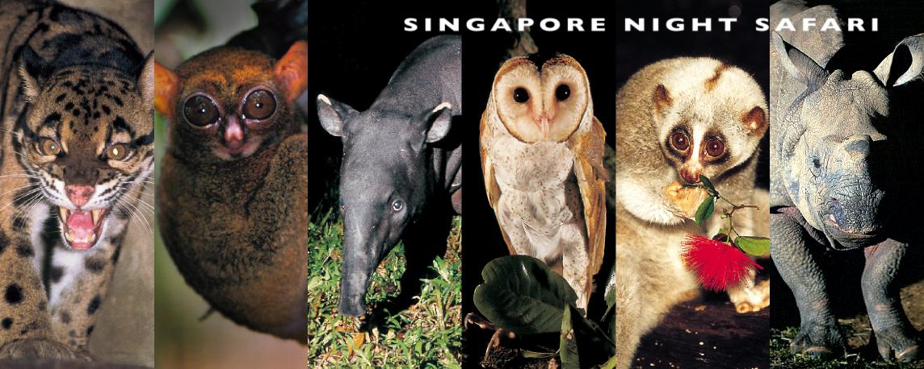

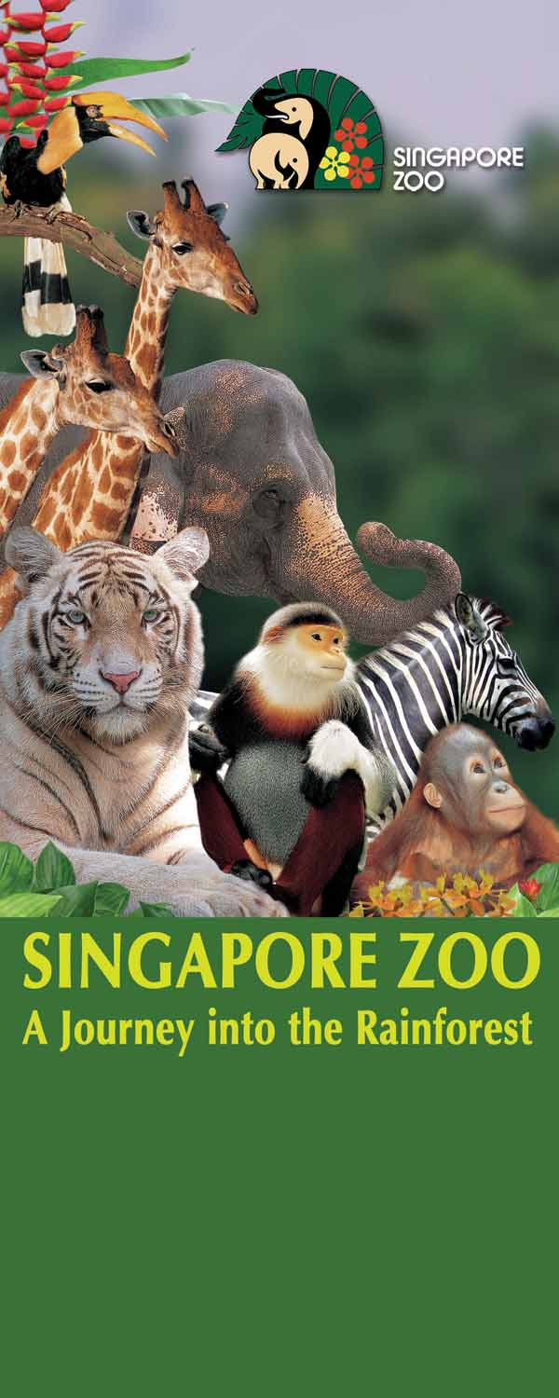
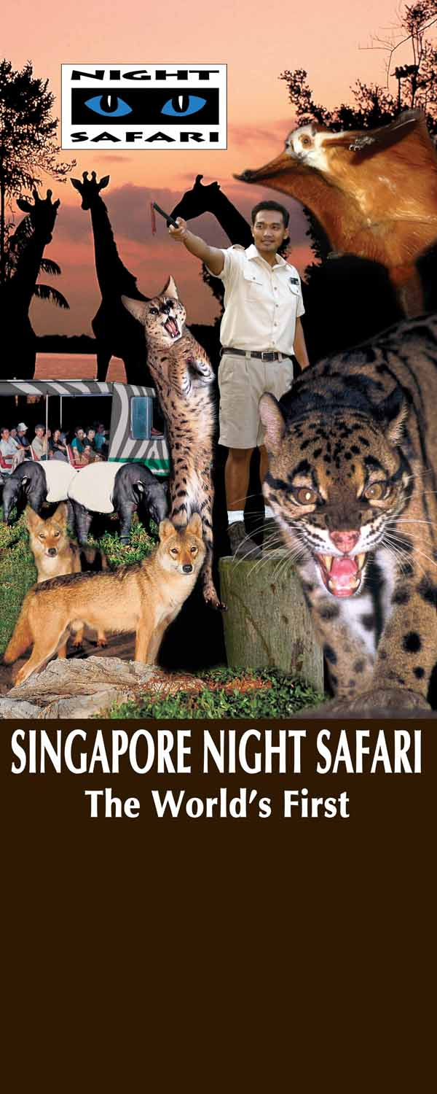

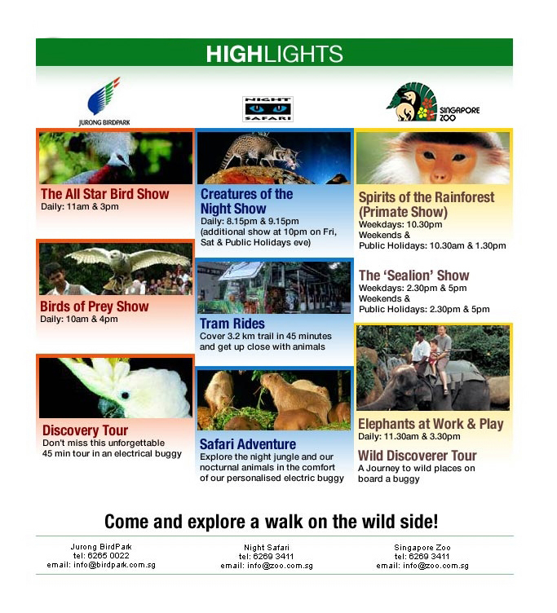

Image courtesy of the Singapore Zoological Garden & Singapore Tourism Board

